1. When sorting by a particular column, what does the sortOrder parameter contain?

The sortOrder contains a string that specifies the column sorted by and whether or not it should be sorted in descending order.

1. How does the program tell whether ascending or descending order is being requested?

The program knows through the hyperlink that was clicked returning a value that is evaluated OnGetAsync as sortOrder deciding which order to use through a switch statement of possible values.

1. What happens in the sorting process when the page is first loaded, and before the user actually changes the sort order by clicking on a column?

OnGetAsync is called and orders the columns by Last Name Ascending.

1. What method/technique is used to specifiy the column to sort by?

The method used Linq to Entities to specify the column to sort by.

1. When is the query to sort the data actually processed?

Only once ToListAsync is called on studentIQ

1. Do a couple screen prints showing the data being sorted by name then date.

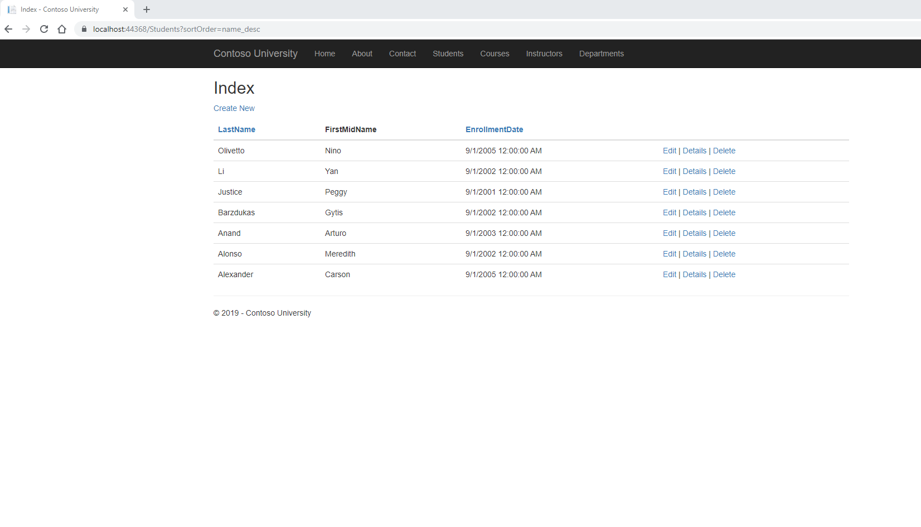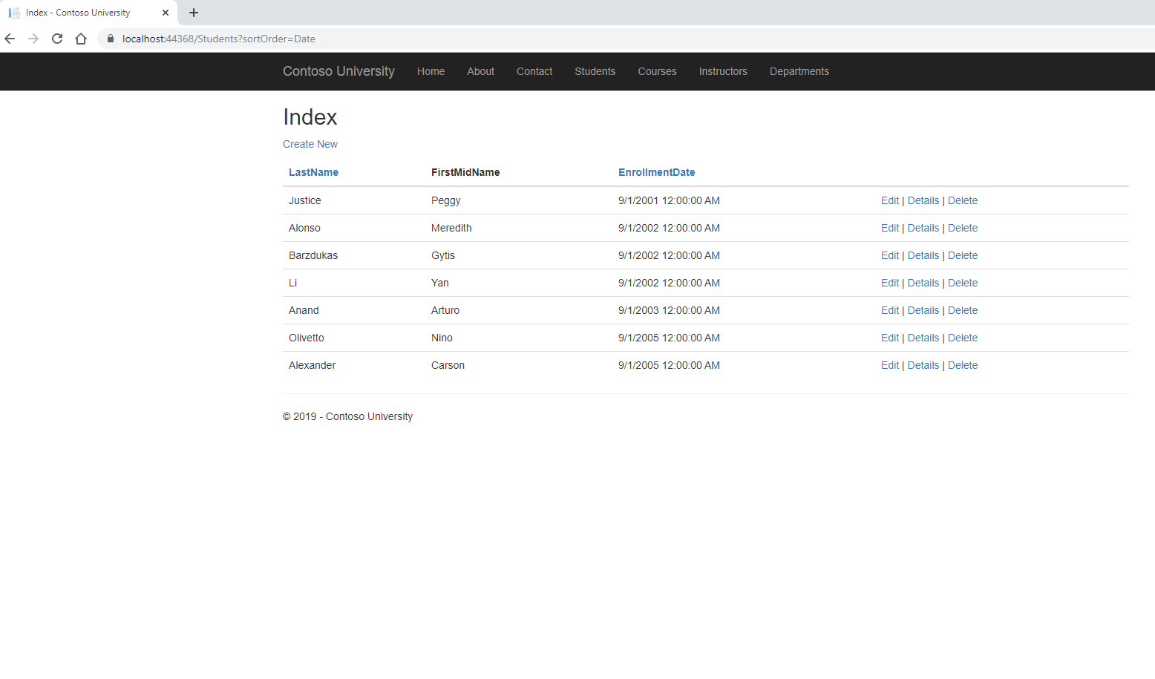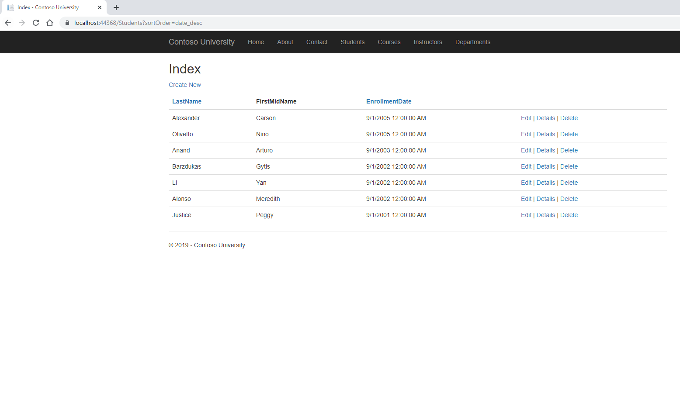

1. When adding filtering capability to limit what rows get displayed to the user, what are the concerns with adding ToUpper to the value being searched for?

ToUpper causes a performance penalty as it prevents the optimizer from using an index slowing us down.

1. When do W3C guidelines suggest using HTTP GET versus HTTP POST when searching?

HTTP POST passes the parameters in the HTTP body while HTTP GET passes the parameter through the URL allowing users to bookmark the page W3C Guidelines suggest that you use HTTP GET if the action doesn’t require an update.

1. Do a couple screen prints showing a search result of your choice, both found and not found.

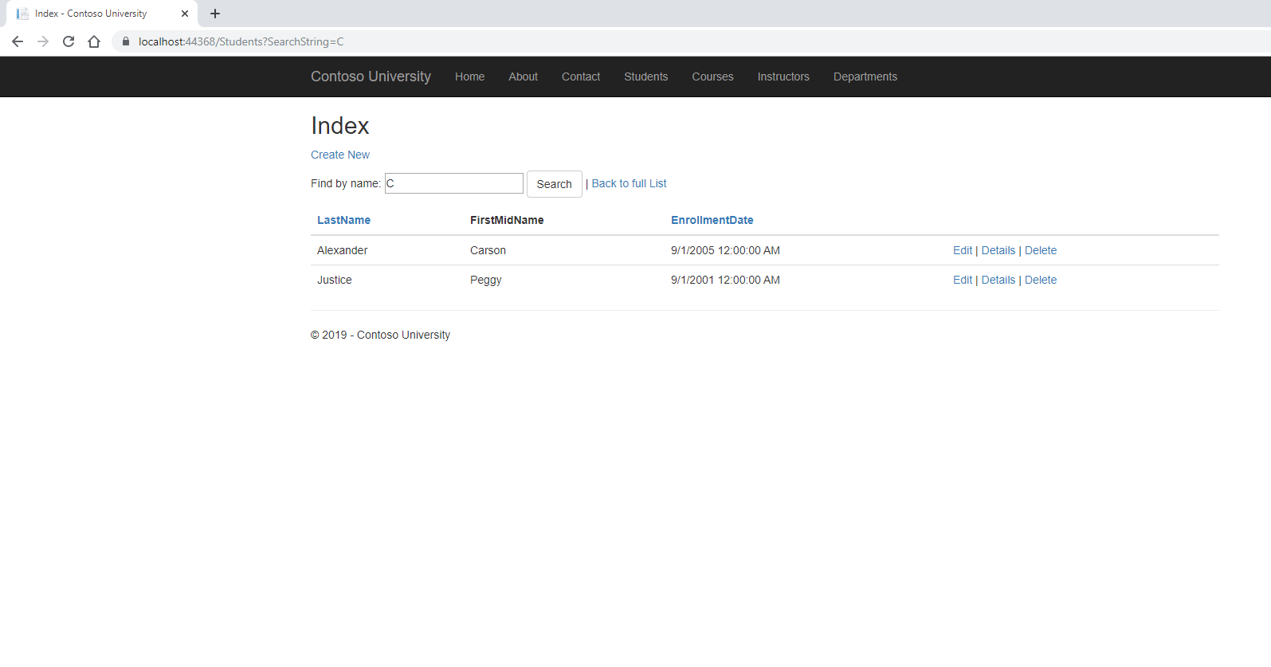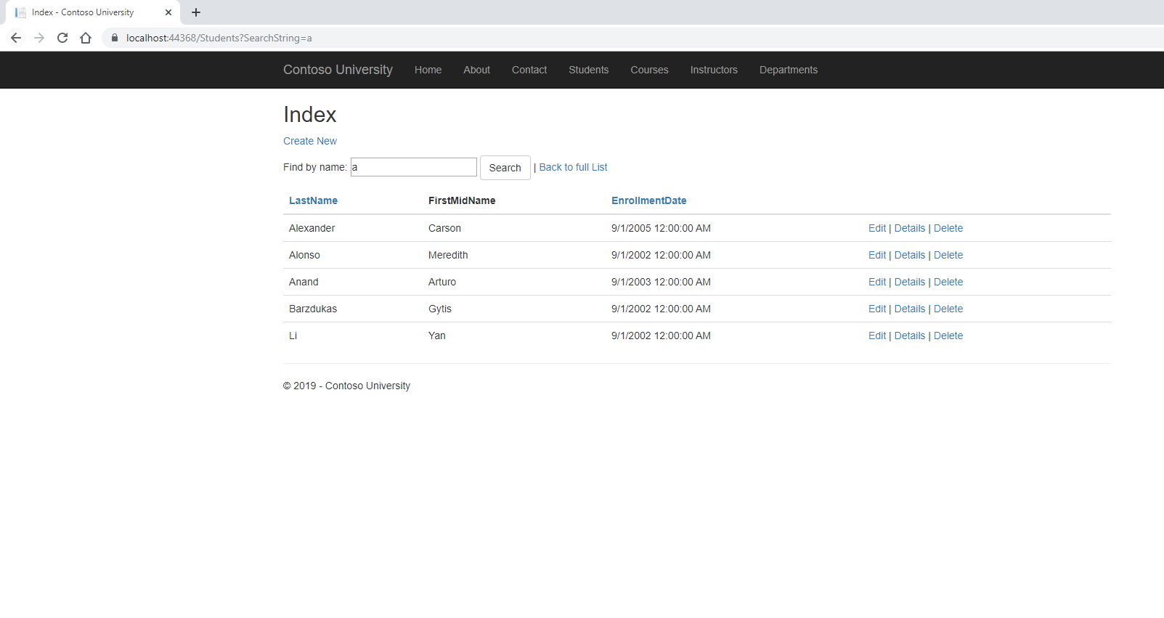

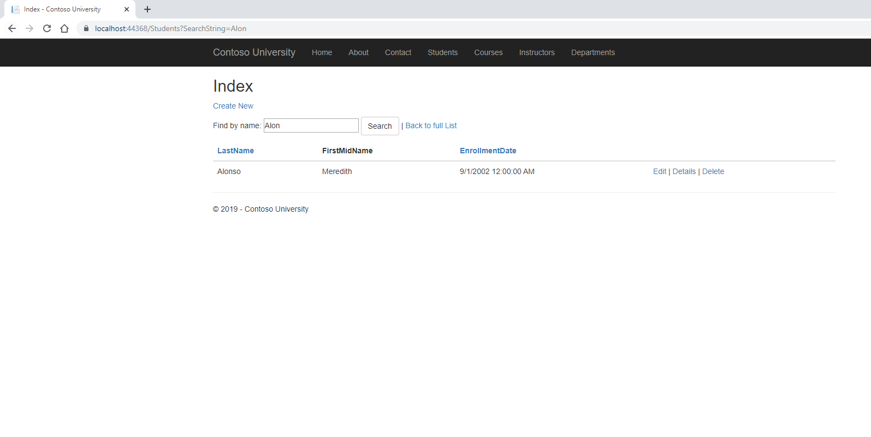

1. What is the null-coalescing operator and what is it’s purpose when paging?

A null-coalescing operator sets the default a default value if the value is null which is useful when paging as when you arrive on a page your navigation value may be null since no page has been specified.

1. Do screen prints showing page forward and page previous working, both with and without a filter.

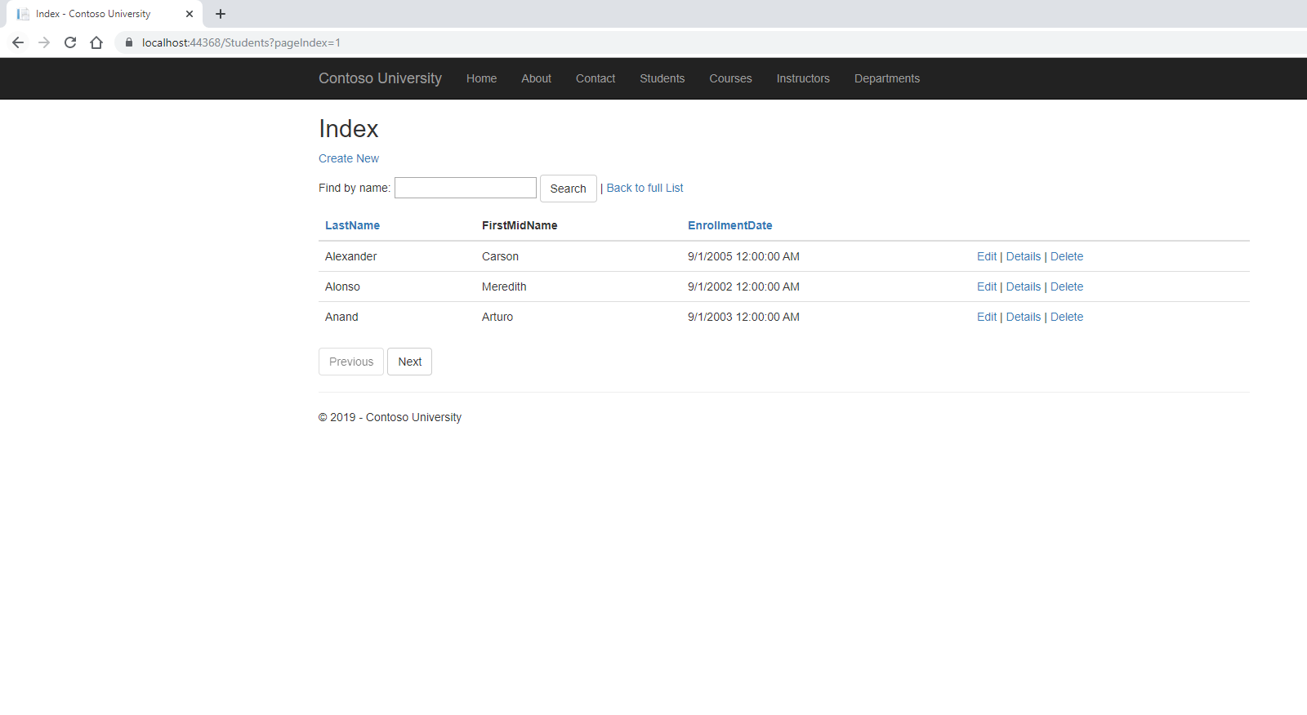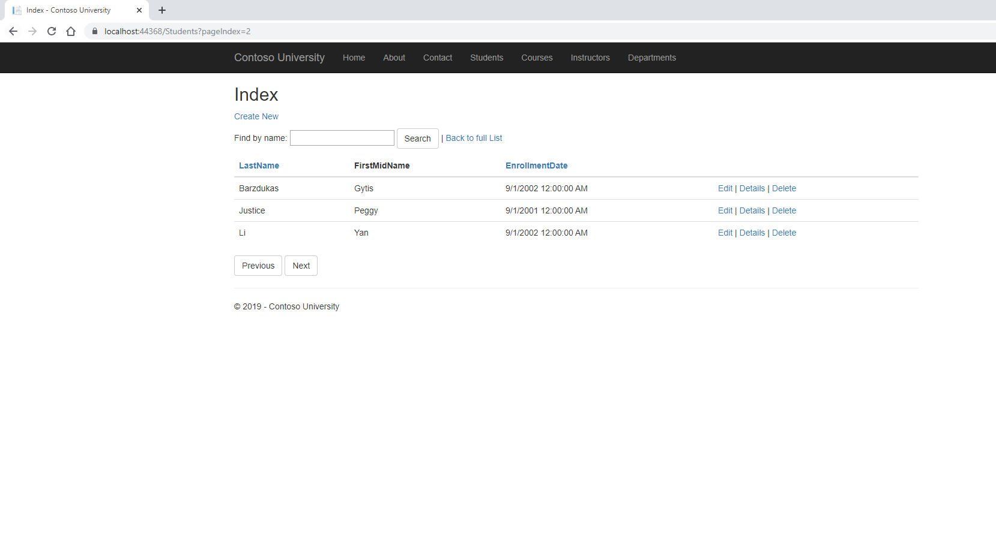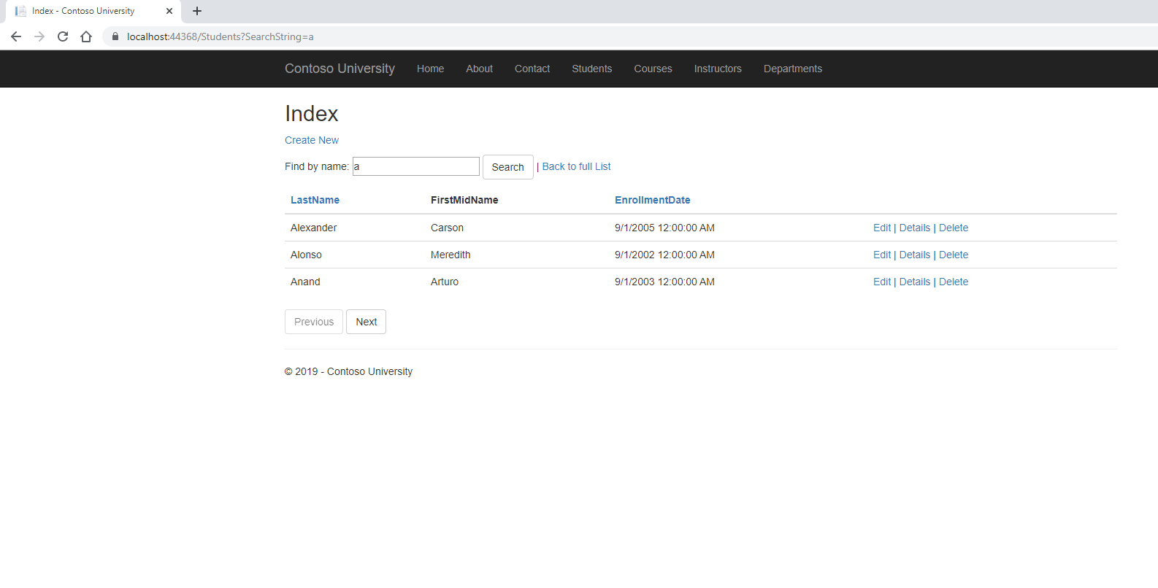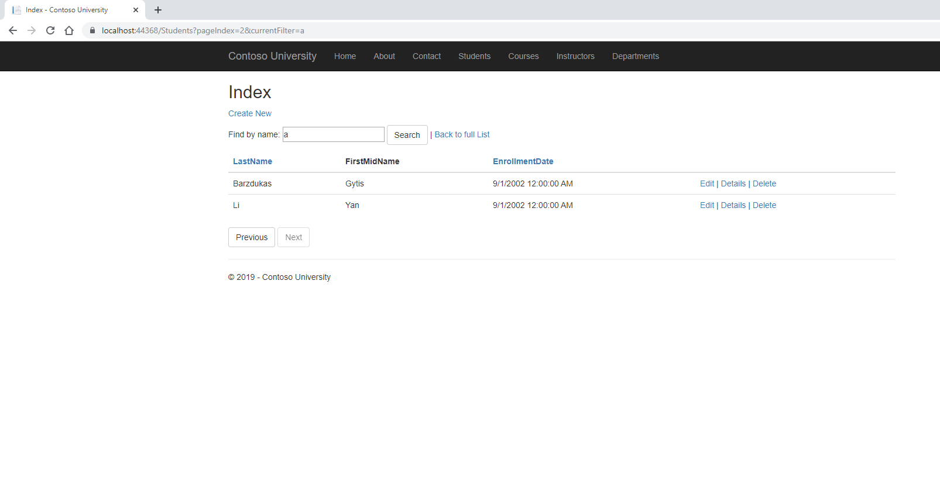

1. Do a screen print of the revised About page showing student enrollment statistics.

